Screenshots of final project:

**Admin:**

* Login:

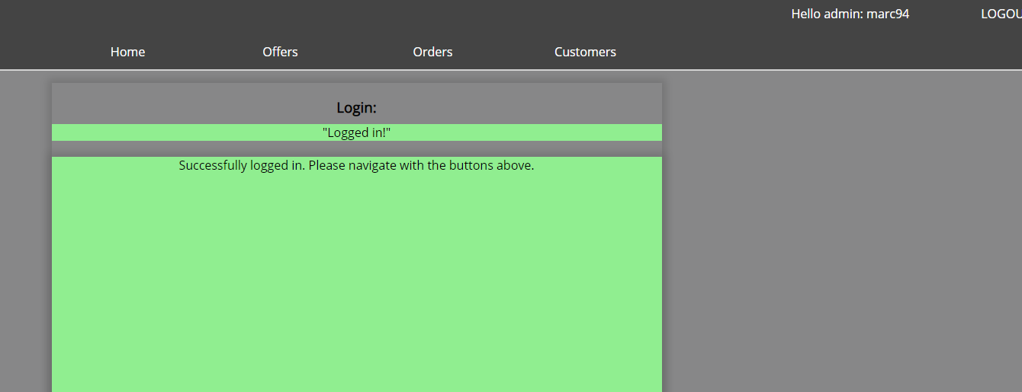

Offer:

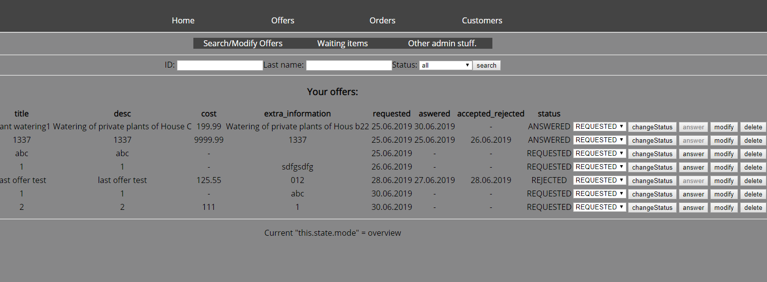

Order:

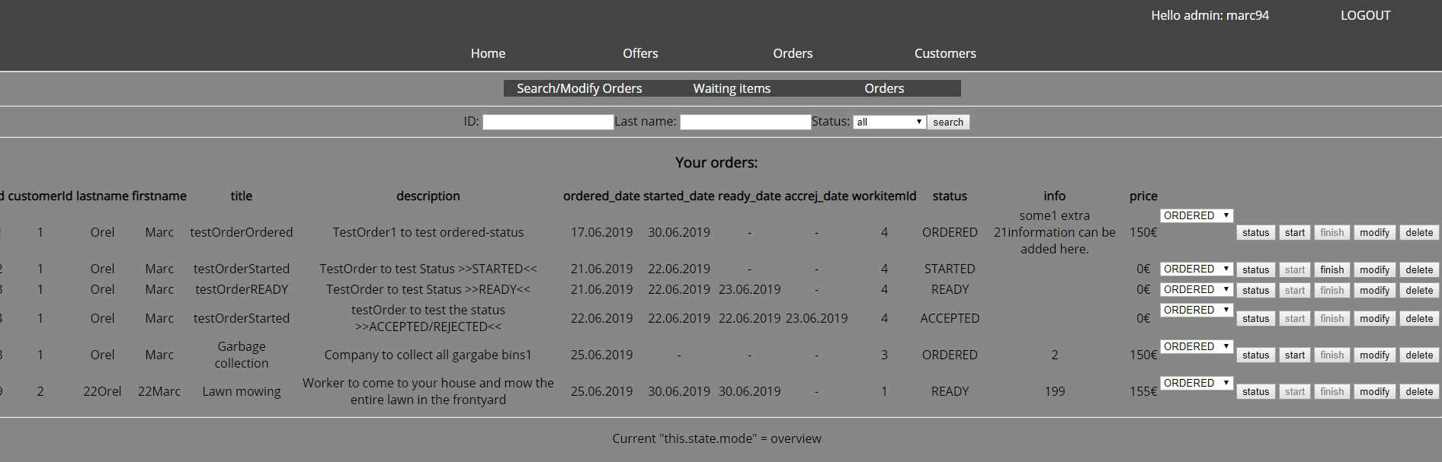

Consumer:

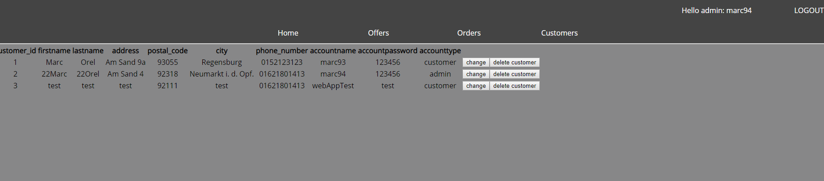

Profile:

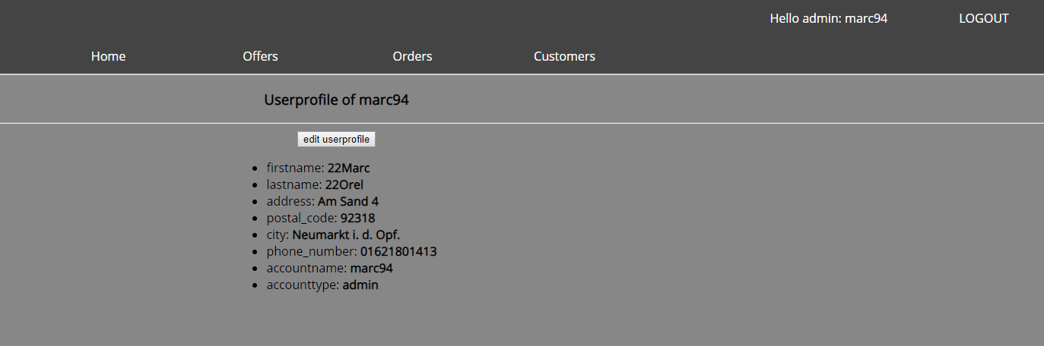

**Customer:**

Login

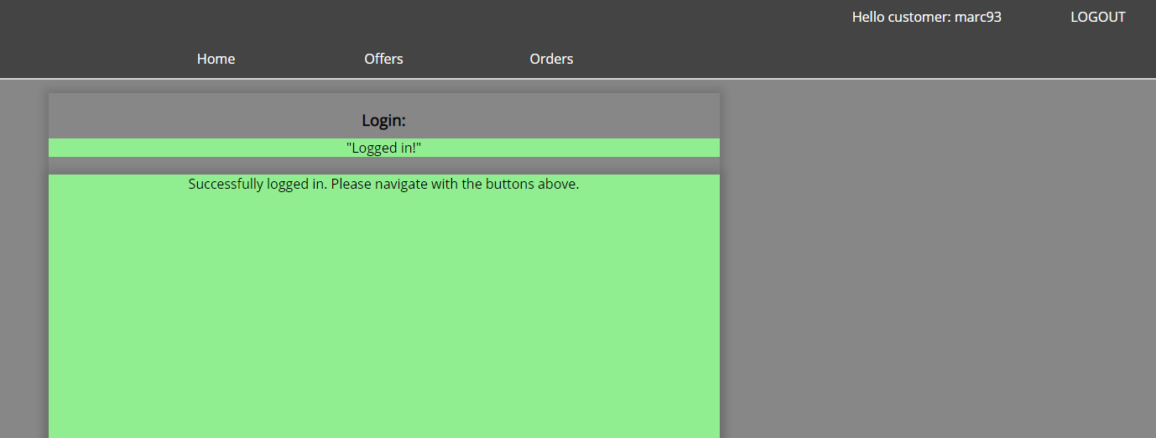

Offers:

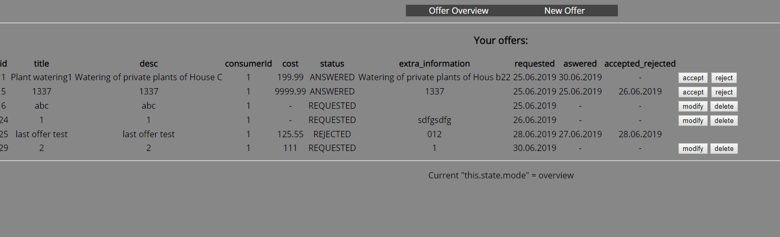

Orders:

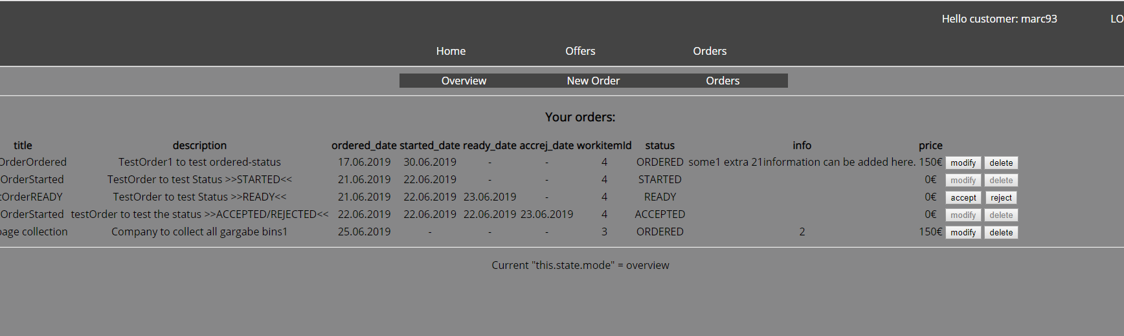

New order:

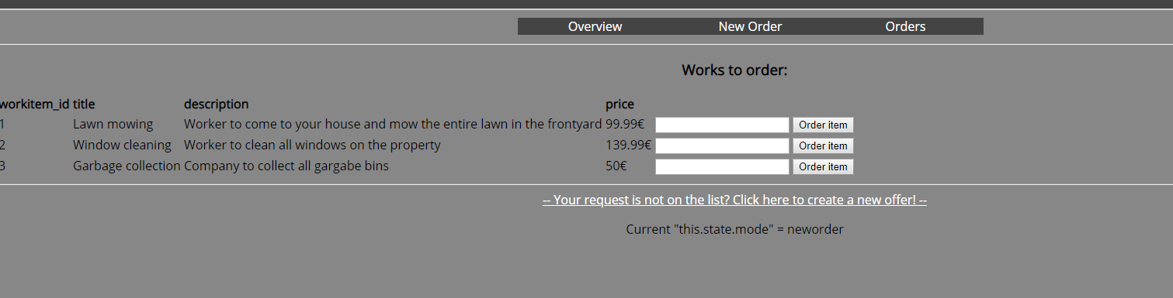

New offer:

